MATTITUCK-LAUREL LIBRARY

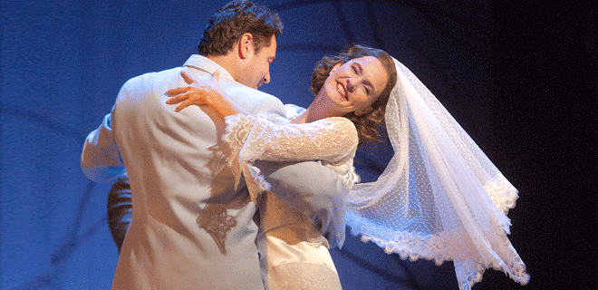

**Invitation to the Opera: *Le Nozze di Figaro***

You are invited to the opera at your community library, Wednesday, June 29th, at 1:30 P.M. with Le Nozze di Figaro, a HD full-length production, from Met Opera on Demand, streamed online and shown on our large screen in the Meeting Room downstairs. (3 hrs 18 min).

Richard Eyre’s elegant production, which opened the Met’s 2014 season, sets the action of Mozart’s timeless social comedy in a manor house in 1930s Seville. Ildar Abdrazakov leads the cast as the resourceful Figaro set on outwitting his master, the philandering Count Almaviva, played by Peter Mattei.

Register at our website under “Programs,” or at the Reference Desk.

**Wednesday, June 29th, 1:30 P.M**