MATTITUCK-LAUREL LIBRARY

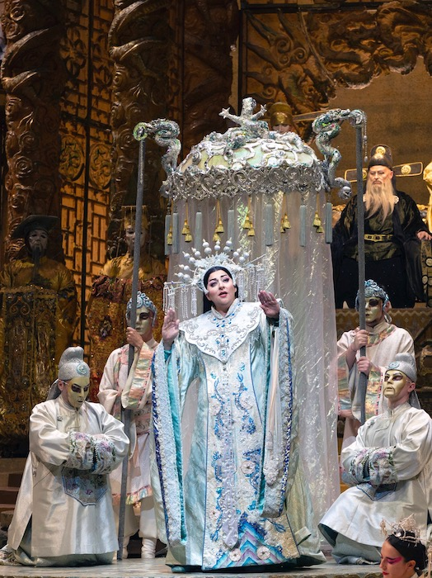

**Invitation to the Opera:**

***Turandot***

Christine Goerke performs the title role in Puccini’s Turandot

You are invited to the opera at your community library, Wednesday, July 27th, at 12:30 P.M. with Turandot, an HD full-length production, from Met Opera on Demand, streamed online and shown on our large screen in the Meeting Room downstairs. (2 hrs 23 min).

In this performance from October, 2019, Christine Goerke stars alongside tenor Yusif Eyvazov (as Calàf) and soprano Eleonora Buratto (as Liù) in Franco Zeffirelli’s classic staging, which dazzles with its opulent visions of mythic China.

Register at our website under “Programs,” or at the Reference Desk

**Wednesday, July 27th, 12:30 P.M**